**XIV setup scripts**

These scripts are mostly a list of individual cli commands.

In scripts for logical add XIV storage I am using a preview mode to make sure that everything is OK.

The script will substitute all variables and list all commands exactly the same way they will be executed.

This is a good way to check the scripts before real execution. The same idea could be used for other devices as well.

To illustrate the idea, this is is the beginning of one script:

[dzunic@oc6028821555 BLD_091-101_setup]$ cat 2-08_1_xiv_gen3_POD1_09_4TB_volmapping.ksh

#

# Ask the preview question

#

echo -e " For preview type yes or y [default=yes]\n For execution type x "

read answer

answer=`echo $answer | awk '{print toupper($1)}'`

if [[ $answer = YES || $answer = Y || $answer = "" ]]

then

preview=echo

user=dummy

pw=dummy

elif [[ $answer = X ]]

then

preview=""

# default user

DEFUSER=us2d9999

echo -n "Enter username [$DEFUSER]:> "

read user

[[ -z $user ]] && user=$DEFUSER

#uncomment the line below if you do not want pw to be seen when you are typing

#stty -echo

echo -n "Enter password for $user:> "

read pw

stty echo

echo

else

echo " Wrong answer !!!!"

exit 33

fi

# Installation Site

site=usbd

# Server Instance Number

Instance_No=09

# pod number

nn=01

# zone (a or b)

zone=a

# volume size (GB)

# 3 TB diss: vols=4852

# 4 TB disks: vols=6504

vols=6504

# POD1 XIV#09

# Please confirm Pool names are correct

XIV09p_POOL="$site"_"$nn""$zone"_xiv_"$Instance_No"_sas_"$vols"gb_r1

# Do not touch below line

svc1p="$site"svc011ccpl1

ip09p=146.89.142.214

echo "Mapping Volume POD1 XIV 09"

echo -e "\nMapping Volumes in the pool $XIV09p_POOL\n"

$preview xcli -m $ip09p -u $user -p $pw map_vol cluster=$svc1p vol="$XIV09p_POOL"_001 lun=1

$preview xcli -m $ip09p -u $user -p $pw map_vol cluster=$svc1p vol="$XIV09p_POOL"_002 lun=2

$preview xcli -m $ip09p -u $user -p $pw map_vol cluster=$svc1p vol="$XIV09p_POOL"_003 lun=3

$preview xcli -m $ip09p -u $user -p $pw map_vol cluster=$svc1p vol="$XIV09p_POOL"_004 lun=4

$preview xcli -m $ip09p -u $user -p $pw map_vol cluster=$svc1p vol="$XIV09p_POOL"_005 lun=5

$preview xcli -m $ip09p -u $user -p $pw map_vol cluster=$svc1p vol="$XIV09p_POOL"_006 lun=6

...

Executing this script in the preview mode will display:

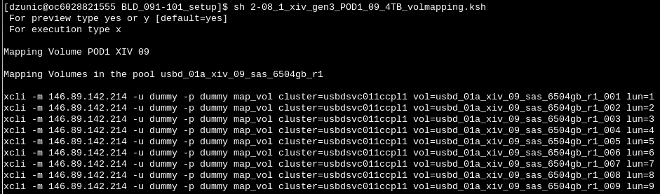

If we are satisfied with the preview output, we can run the script in an execution mode:

